The Arabs
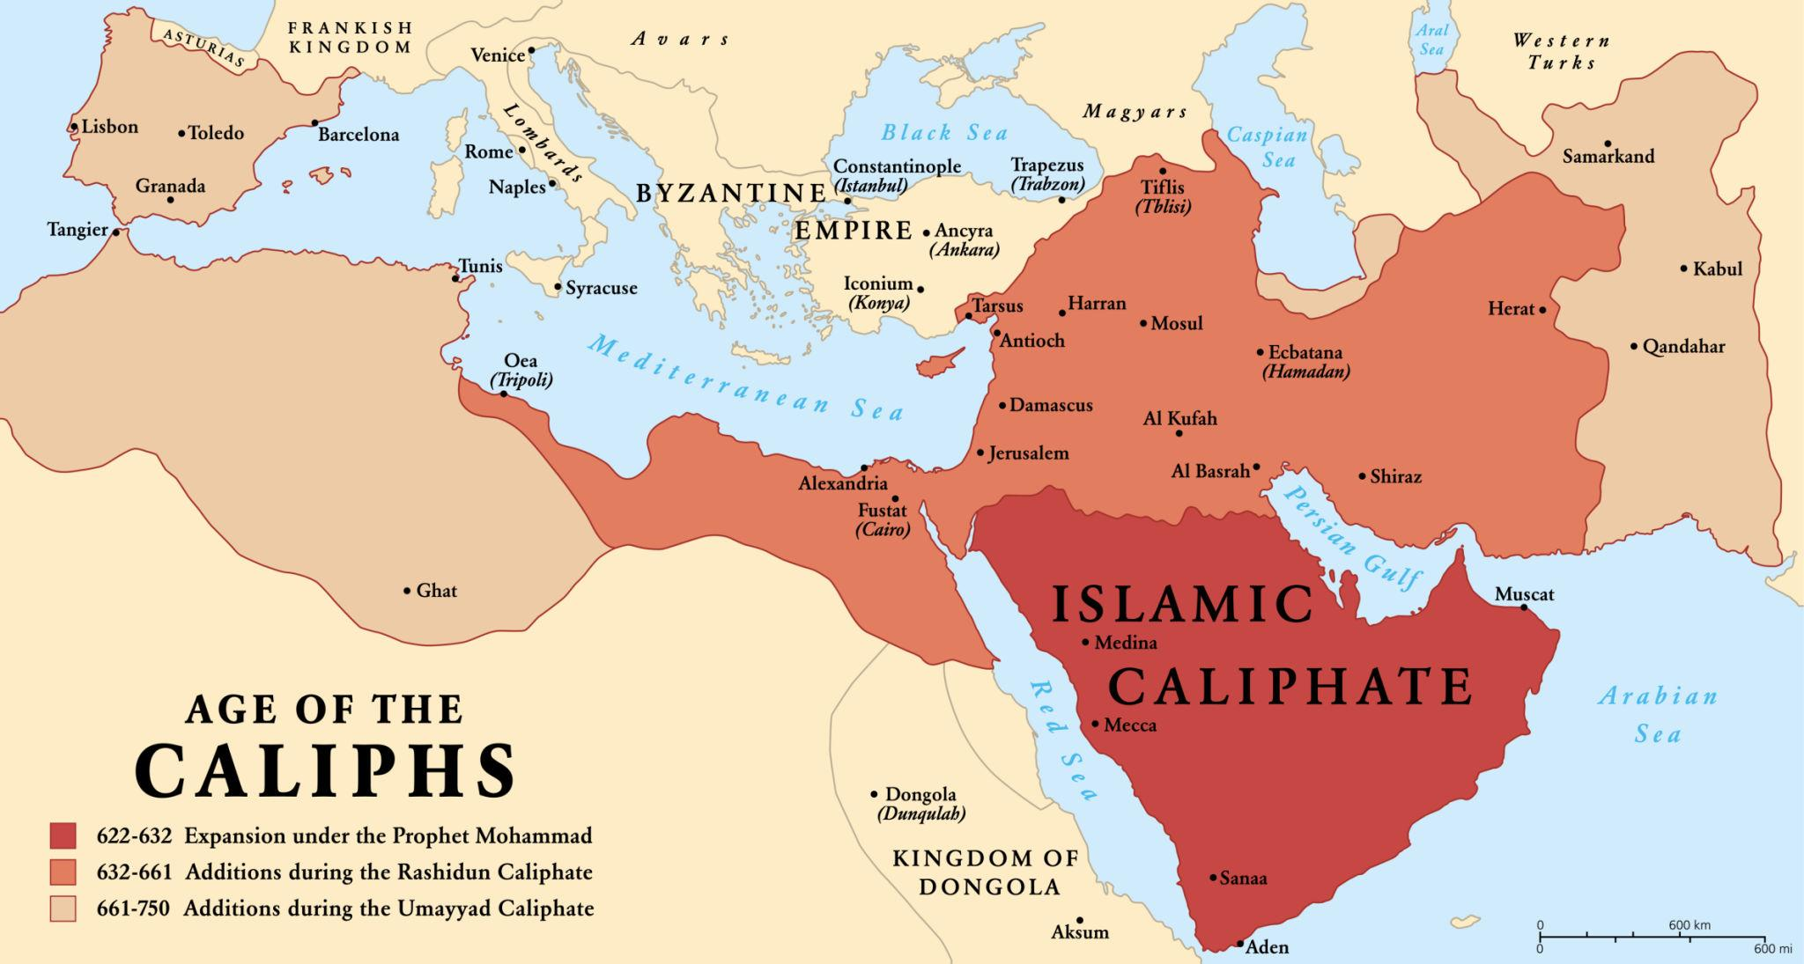
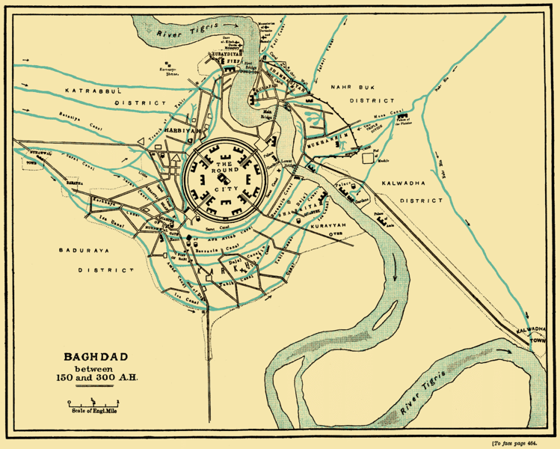
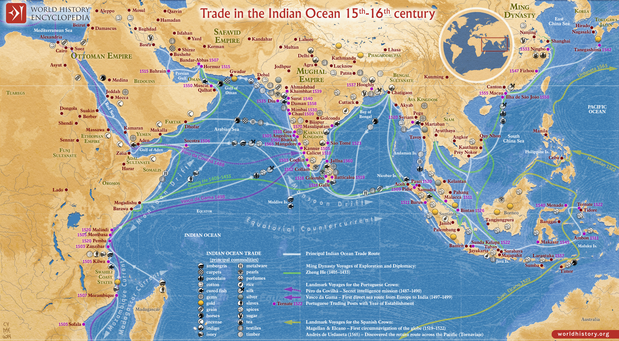
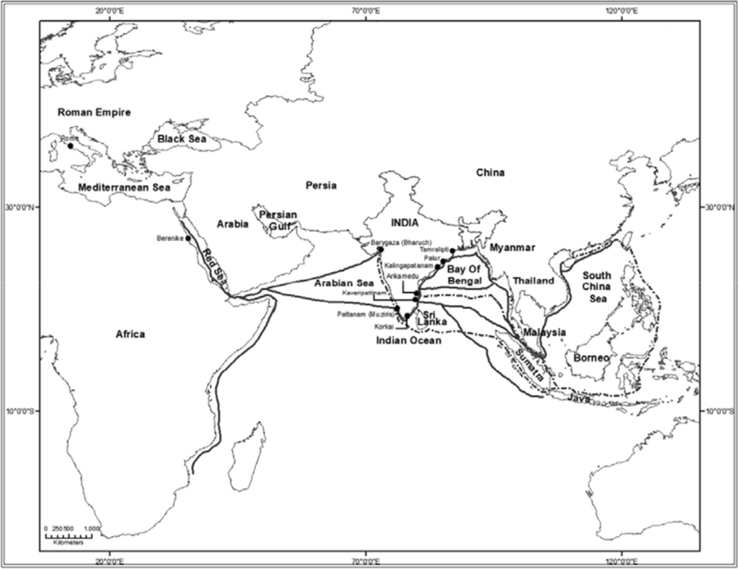
Introduction
The Arabs originated in the Arabian Peninsula, a region characterised by vast deserts, scattered oases, and important caravan trade routes linking Asia, Africa, and the Mediterranean world. After the rise of Islam in the seventh century, the Arabs rapidly expanded beyond Arabia and established a vast empire stretching across West Asia, North Africa, and parts of Europe. Arab civilisation became one of the most influential forces of the medieval world, contributing significantly to political organisation, economic networks, and intellectual development.
Expansion of the Arab Empire
Following the emergence of Islam in the seventh century, Arab political power expanded rapidly under the leadership of the Caliphs. Within a few decades, Arab armies conquered large territories that had previously belonged to the Byzantine and Persian empires. Regions such as Syria, Palestine, and Egypt were brought under Arab control, followed by the conquest of Persia and large parts of North Africa. Arab forces also crossed into Europe and established Muslim rule in Spain, known as Al-Andalus.
These conquests created a vast empire that connected the Mediterranean world with the Middle East, Central Asia, and North Africa. The rapid expansion of Arab power was facilitated by the military organisation of the Arab armies, the internal weaknesses of the Byzantine and Persian empires, and the appeal of Islamic rule in newly conquered regions.
Administration and Government
The Arab Empire was governed by the Caliph, who served as both the political ruler and the religious leader of the Muslim community. The Caliphate developed an administrative system that was partly influenced by earlier Byzantine and Persian models. The empire was divided into provinces, each governed by appointed officials responsible for maintaining order, collecting taxes, and administering justice.
Arabic gradually became the language of administration and government, helping to unify the diverse regions of the empire. Non-Muslims living under Arab rule were generally allowed to practice their religion, although they were required to pay a special tax known as jizya. This administrative system helped maintain political stability across the vast territories of the empire.
Economic Life and Trade
One of the most significant features of Arab civilisation was its strong connection with long-distance trade networks. The Arab Empire occupied a strategic position between Asia, Africa, and Europe, enabling it to control important commercial routes. Merchants transported a wide range of goods such as spices, silk, textiles, precious metals, and agricultural products across these regions.
Major urban centres such as Baghdad, Damascus, and Cairo became thriving centres of commerce and cultural exchange. Agricultural improvements, including the use of irrigation techniques and the introduction of new crops, also contributed to economic growth within the empire.
Cultural and Intellectual Achievements
Arab civilisation made remarkable contributions to science, learning, and culture. Scholars in the Islamic world preserved and translated important works of Greek philosophy, science, and medicine. These translations helped safeguard classical knowledge and made it available to later generations.
Arab scholars also made original contributions in fields such as mathematics, astronomy, medicine, and geography. The development of algebra, improvements in medical knowledge, and advancements in astronomical observation were among the significant achievements of this period. In addition, Arabic literature, poetry, and historical writing flourished, reflecting the intellectual vitality of the Islamic world.
Conclusion
In conclusion, the Arabs played a crucial role in shaping the political, economic, and cultural landscape of the medieval world. Through their rapid expansion, they created a vast empire that connected different regions of Asia, Africa, and Europe. Arab civilisation became an important centre of trade, learning, and cultural exchange, preserving ancient knowledge and contributing new ideas to the development of world civilisation. The legacy of Arab achievements continued to influence both the Islamic world and medieval Europe for many centuries.

