Vernalization

Vernalization refers to the process of growing flowers and fruits through a phase of cold treatment. It reduces the time period of the juvenile vegetative growth phase in the plants. The active meristematic cells of the shoot apex, root apex, embryo tips etc., participate in the production of a stimulus Vernalin.

The term vernalization has been originated from the Latin word Vernalis, i.e. “of the spring”. Before plant reproduction, it allows vegetative maturity. The process of vernalization is significantly employed in food plants (wheat, barley, rye etc.), biennial plants (cabbage, sugar beet etc.) and perennial plants (like chrysanthemum).

- Vernalization is a biological process in which exposure to prolonged cold induces flowering in plants. This mechanism ensures that flowering occurs in favourable conditions, primarily in spring, after the cold winter period has passed. Plants undergoing vernalization acquire the ability to flower, though additional seasonal conditions may still be required to complete the process.

- The process plays a crucial role in temperate climates where many plants must experience low temperatures to trigger reproductive development. Without vernalization, these plants would face challenges in timing their flowering and seed production. This cold period is measured in “chill hours,” and optimal temperatures for vernalization usually fall between 1°C and 10°C.

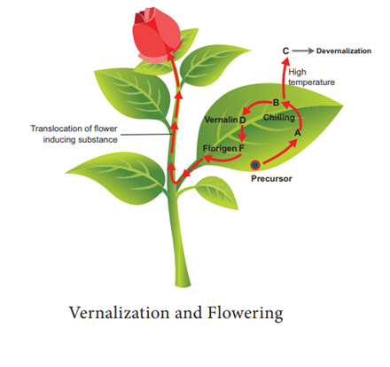

- In perennial plants, such as fruit trees, cold periods induce dormancy, which is a necessary phase before the plant can flower. Similarly, annuals and biennials, like certain cereals and Arabidopsis thaliana ecotypes, require cold exposure to flower. This adaptation ensures that these plants do not flower prematurely, ensuring their reproductive cycle aligns with favorable environmental conditions.

- Vernalization can be classified into two types: facultative and obligate. Facultative vernalization triggers earlier flowering in response to cold, while obligate vernalization requires a specific period of cold exposure before flowering is initiated.

- The phenomenon of vernalization has been studied since the 19th century, with key contributions from scientists like John Hancock Klippart, who first demonstrated the effects of winter temperatures on germination. In 1928, Lysenko formally introduced the concept of vernalization, defining it as the chilling of seeds to promote flowering.

- Overall, vernalization is a critical adaptation that allows plants to synchronize their flowering and reproduction with seasonal changes, ensuring survival and successful seed production in fluctuating environments.

Definition of Vernalization
Vernalization refers to the process in which the seedling is subjected to low temperature (5-10 degrees Celsius) during winter, and by the development of flowers and fruits, the seedling is exposed to a high temperature (about 40 degrees Celsius).

Therefore, it merely refers to the process of going dormant in the cold temperature. The process of subjecting seedlings from the cold temperature to the high temperature is called devernalization. The temperature and the time period of the chilling process depend upon the plant species.
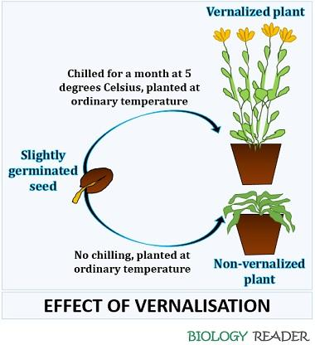
A plant depends (both qualitatively and quantitatively) upon exposure to the cold temperature to develop reproductive structures like flowers and fruits. The temperature has a major effect on germination, growth and metabolic activities.

The plants must need exposure to cold treatment for germination and flowering in plants, whether they grow at a high or low temperature.
Vernalization occurs in two ways, namely facultative and obligate.

- Facultative vernalization results in early flowering once the seedling is subjected to a low temperature.
- Obligate vernalization requires exposure of the seedling to the desired time period to induce flowering.

Obligate Vernalization

- Definition: This type of vernalization is essential for flowering. Plants requiring obligate vernalization must undergo a cold exposure period to initiate flowering.
- Function: Without this cold period, these plants will not flower, regardless of other environmental factors like light.

- Examples: Cabbage, winter wheat, and barley are typical examples. These plants rely entirely on this cold period to complete their reproductive cycle.
- Duration and Temperature: The cold period required can vary significantly among species. For instance, winter wheat necessitates a more extended cold exposure compared to spring wheat. The ideal temperatures for obligate vernalization generally range from 0°C to 10°C (32°F to 50°F).

Facultative Vernalization

- Definition: Facultative vernalization is not essential for flowering but can accelerate the process. Plants with this type of vernalization can flower even without cold exposure, although it may occur later.
- Function: Cold exposure shortens the time to flowering, making the plant’s reproductive cycle more efficient under optimal conditions.
- Examples: Spinach, carrots, and beets exhibit facultative vernalization. These plants will flower eventually even without a cold period, though flowering will be delayed.
- Duration and Temperature: While the exact requirements can differ, the exposure to lower temperatures generally speeds up flowering rather than being a strict necessity.

History
Many contributors gave their different theories and approaches to describe the phenomena of vernalization.
Year | Discoverer | Discovery
1857 | John Hancock Klippart | Demonstrated the effect of winter temperature on germination
1918 | Gustav Gassner | Published an article to differentiate specific requirements of winter from the summer plants
1928 | Lysenko | Introduced the chilling process on cereal seeds and given the term vernalization
1960 | Chourad | Defined vernalization as a process of accelerating flowering in plants by the chilling treatment

Mechanism of Vernalization

Vernalization involves a series of physiological processes that enable plants to flower after being exposed to prolonged cold temperatures. This process ensures that flowering occurs in optimal environmental conditions, generally in spring. The mechanism of vernalization can be understood through two primary theories: the Phasic Development Theory and Hormonal Theories.

Phasic Development Theory
- Overview: Proposed by Lysenko in 1934, this theory describes plant development as occurring in sequential phases influenced by environmental factors such as temperature and light.

- Phases:
  - Thermophase: This initial phase requires exposure to cool temperatures. Vernalization accelerates this phase by promoting the plant’s readiness to transition to the next stage. Essential conditions include not only low temperatures but also adequate moisture and aeration.
  - Photophase: Following the thermophase, plants enter this stage, which necessitates warmer temperatures and light. The transition to this phase leads to the production of floral structures.

  - Function: The completion of the thermophase, accelerated by vernalization, prepares the plant for the subsequent photophase, during which flowering is initiated.

Hormonal Theories

- Overview: First proposed by Melcher in 1939, this theory suggests that cold exposure induces the production of a specific floral hormone.
- Vernalins: This floral hormone, known as vernalin, is produced during cold exposure and plays a critical role in flowering. Vernalin moves through the plant and can even induce flowering in plants that were not directly exposed to cold.
- Experimental Evidence: Melcher demonstrated that grafting a vernalized plant with an unvernalized plant could induce flowering in the latter. This indicates that vernalin can diffuse from the vernalized plant and stimulate flowering in the unvernalized plant.

It involves the following steps:
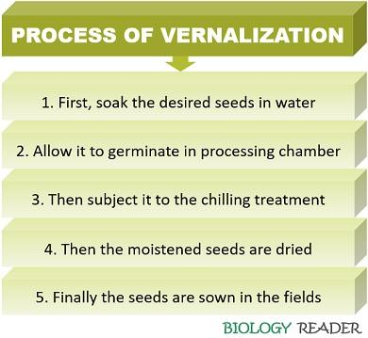
- Seed moistening: First, soak the seeds in water and later allow them to germinate in the processing chamber under 10-12 degrees Celsius.
- Chilling treatment: Expose the germinated seeds to the low temperature (3-5 degrees Celsius) upto desired time.
- Drying and sowing: Seeds are then dried and sown in a field with adequate water and oxygen supply.

There are two hypotheses, which explain the theory of vernalization.
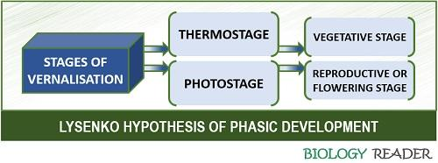
- Thermostage: It refers to the primary stage, where the slightly germinated seeds are exposed to a low temperature of 0-5 degrees Celsius in the presence of oxygen and moisture. During this stage, structures like root, stem, and leaves develop, known as the vegetative phase. Here, the seed loses its dormancy and starts to germinate.
- Photostage: It is the secondary stage when the seedlings are subjected to the phase of correct photoperiod or high temperature upto 40 degrees Celsius. It refers to the reproductive stage, where the seedlings grow the reproductive structures like flowers and fruits.

The hypothesis of hormonal involvement
According to Chailakhyan, the vernalization method has two possibilities:
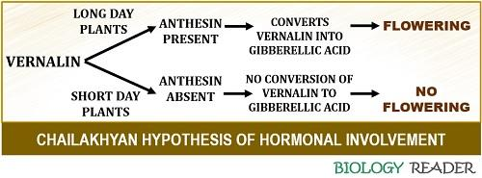
- In long-day plants: A flowering hormone anthesin in long-day plants converts vernalin hormone into a growth-regulating hormone gibberellic acid, which finally induces flowering in plants.
- In short-day plants: They lack a flowering hormone anthesin, which converts vernalin into gibberellic acid, thereby inducing no flowering.

Examples of Vernalizatized Plants
- Food plants (wheat, rye, etc.) have both spring and winter varieties. The spring and winter varieties are sown in the spring season and autumn season, respectively.
- Biennial plants (carrot, sugar beet, etc.) take two years to flower. In the first year, a plant undergoes vegetative growth, while in the second year, it becomes dormant during the winter, thereby producing flowers and fruits, and finally dies in the next summer.

- Wheat (Triticum aestivum)
  - Requirement: Wheat requires vernalization to initiate flowering. Without exposure to cold, the plants will remain in a vegetative state.
  - Process: In temperate regions with cold winters, wheat seeds are sown in the autumn. They undergo several weeks of cold treatment, typically between 0°C and 10°C (32°F and 50°F).
  - Effect: The cold conditions induce physiological changes in the plant’s shoot tips, where flower development occurs. This process prepares the plant for flowering once warmer spring temperatures are reached.
  - Outcome: After vernalization, the wheat plants transition from producing leaves to developing flowers, ultimately leading to seed production.

- Arabidopsis thaliana (Mouse-ear Cress)
  - Model Plant: Arabidopsis is frequently used in research to study vernalization due to its short life cycle and well-characterized genetic framework.
  - Experimental Setup: Researchers manipulate environmental conditions to observe how vernalization affects Arabidopsis at the molecular level.
  - Genetic Regulation: In Arabidopsis, genes such as FLC play a crucial role in regulating flowering in response to cold exposure. These genetic mechanisms provide insights into how plants manage flowering timing.
  - Research Applications: Findings from Arabidopsis research contribute to understanding vernalization in other crops, such as wheat and barley, and enhance agricultural practices by improving our knowledge of plant responses to cold.

Factors Affecting
The factors affecting vernalization includes:
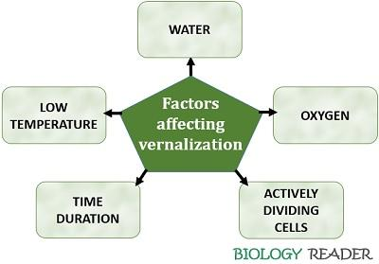
- Low temperature: A general process to grow healthy plants by employing vernalization technique primarily requires a low temperature ranging between 0-10 degrees Celsius. After this, you need to subject the seedlings to a high temperature of 40 degrees Celsius.
- Time period: The time period of vernalization depends upon the plant type, and it can vary from a few days to weeks or even several months.
- Actively dividing cells: The process of vernalization occurs in the germinating seeds, which comprises an active embryo. Thus, the process does not occur in the dry seeds. It requires seeds moistened with active meristematic cells.
- Water and Oxygen: Proper protoplasmic hydration is a prerequisite for the seedling to recognize a stimulus. Vernalization needs adequate oxygen, as it is an aerobic process that regulates the metabolic energy inside plant cells.

Importance
- Vernalization gives adequate time for the plants to get mature and also prevents pre-maturing during their growing season.
- It reduces the vegetative phase and hastens the reproductive period.
- Vernalization increases the plant’s growth and yield.
- Vernalization makes the plants more adaptable by allowing them to grow in regions where they usually don’t grow.
- It also removes wrinkles on the kernels of the Triticale.
- It is not only applicable for growing temperate plants, but also some tropical plants like wheat, rice, millets etc.

Conclusion
Therefore, we can conclude that vernalization is a method of inciting early flowering in plants by the pretreatment of seeds under a low temperature. Reversal of the vernalization process is an effect known as devernalization, which interrupts the process during the period of low temperature into a high temperature.

