SECURITY SERVICES
Security services are the functions provided by a security system to protect data, communication, and resources from unauthorized access, misuse, or attacks.
They are designed to counter security threats and ensure safe communication over networks.
According to the International Organization for Standardization (ISO) security architecture, security services provide protection in information systems.

types of security services

- Authentication Service
Authentication ensures that the identity of a user, device, or system is genuine.

Types of Authentication

a) Entity Authentication
Verifies identity of a user before granting access.
Example: Login using username & password.

b) Data-Origin Authentication
Ensures the message comes from the claimed sender.
Example: Digital signature verification.

Methods of Authentication
- Password-based authentication
- OTP (One-Time Password)
- Biometric authentication (fingerprint, face recognition)
- Multi-Factor Authentication (MFA)
- Digital certificates

2. Access Control Service
Access control restricts access to resources only to authorized users.

Types of Access Control
- Discretionary Access Control (DAC) : Owner of the resource decides who can access it.

Example: File owner giving read/write permission.
- Mandatory Access Control (MAC): Access is controlled by a central authority based on security labels.

Example: Military classified systems (Confidential, Secret, Top Secret)
- Role-Based Access Control (RBAC): Access is granted based on user roles.

Example: HR role → Access salary data

Student role → View results only

3. Data Confidentiality Service
Confidentiality ensures that information is not disclosed to unauthorized persons.

Types of Confidentiality

1. Connection Confidentiality: Protects all user data transmitted during a session.

Example: HTTPS session encryption.

2. Connectionless Confidentiality: Protects individual messages independently.

Example: Encrypted email messages.

3. Selective Field Confidentiality: Only specific parts of data are encrypted.

Example: Only credit card number encrypted in a transaction.

4. Traffic Flow Confidentiality: Protects information about communication patterns.

Example: Using VPN to hide traffic analysis.

Methods to Achieve Confidentiality
- Encryption (Symmetric & Asymmetric)
- VPN
- Secure communication protocols (HTTPS)
- Secure email encryption

Example
When you access a banking website through HTTPS, data is encrypted.

4. Data Integrity Service
Integrity ensures that data is not modified, altered or destroyed in an unauthorized manner.

1. Connection Integrity with Recovery: Ensures data integrity during session and can recover lost data.

Example: Secure file transfer protocols.

2. Connection Integrity without Recovery: Detects modification but does not recover lost data.

3. Selective Field Integrity: Only specific parts of data are integrity-protected.

4. Connectionless Integrity: Protects individual messages without session.

Example: Digital signature on a document.

Mechanisms Used
- Hash functions (SHA)
- Message Authentication Code (MAC)
- Digital signatures

5. Non-Repudiation Service
Non-repudiation ensures that a sender cannot deny sending a message and a receiver cannot deny receiving it.

1. Non-Repudiation of Origin: Sender cannot deny sending the message.

Example: Digital signature verification.

2. Non-Repudiation of Receipt: Receiver cannot deny receiving the message.
Example: Acknowledgment receipts in secure communication.

Mechanism Used
- Digital signatures
- Public Key Infrastructure (PKI)

Example
Online contracts signed digitally cannot be denied later.

6. Availability Service
Availability ensures that authorized users can access systems and data whenever needed.

Methods to Ensure Availability
- Backup systems
- Redundant servers
- Load balancing
- Disaster recovery planning

TYPES OF SECURITY MECHANISM

Security mechanisms are techniques and controls used to protect data and systems from unauthorized access, attacks, and misuse by ensuring confidentiality, integrity, and availability.
- Designed to safeguard information and system resources
- Ensure confidentiality, integrity, and availability (CIA triad)
- Classified into Specific and Pervasive security mechanisms
- Used across OSI layers to prevent, detect, and recover from attacks

Types of Security Mechanisms

Security mechanisms are broadly classified into two:
- Specific Security Mechanisms
- Pervasive Security Mechanisms

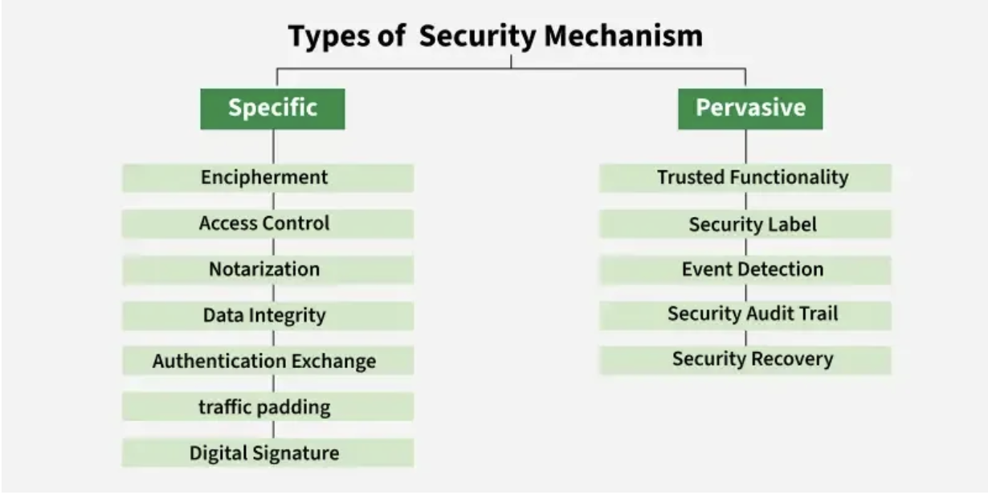

1. Specific Security Mechanisms

These mechanisms operate at specific OSI layers and provide targeted security services.

Key Types

1. Encipherment
- Protects data confidentiality by converting readable data into unreadable form
- Uses cryptographic algorithms
- Strength depends on the encryption technique used

2. Access Control
- Prevents unauthorized access to data or systems
- Implemented using passwords, PINs, firewalls, or access policies

3. Notarization
- Uses a trusted third party to validate communication
- Helps resolve disputes by maintaining transaction records

4. Data Integrity
- Ensures data is not altered during transmission
- Achieved using checksums, hashes, or message authentication code

5. Authentication Exchange
- Verifies the identity of communicating entities
- Often uses handshaking mechanisms to confirm sender and receiver identities

6. Bit Stuffing
- Adds extra bits to data for error detection
- Commonly uses even or odd parity checks

7. Digital Signature
- Confirms sender identity and message authenticity
- Uses cryptographic techniques
- Ensures non-repudiation and data integrity

2. Pervasive Security Mechanisms

These mechanisms apply across all OSI layers and support overall system security.

Key Types:
1. Trusted Functionality
- Built-in security features of a system
- Ensures reliable enforcement of security rules

2. Security Labels
- Tags data with classifications like Public, Confidential, or Top Secret
- Helps control access and handling of information

3. Event Detection
- Monitors systems for abnormal or suspicious activities
- Helps identify potential security threats early

4. Security Audit Trail
- Maintains logs of system activities such as logins and file access
- Useful for monitoring, investigation, and accountability

5. Security Recovery
- Restores systems after a security breach
- Ensures continuity and protection of data

Difference Between Specific and Pervasive Security Mechanisms

The following table shows the key differences between specific and pervasive security mechanisms, showing how each type plays an important role in protecting an information.

Specific Security Mechanisms | Pervasive Security Mechanisms
Applied to specific OSI layers | Applied across all OSI layers
Provide targeted security services like encryption and authentication | Support overall security and policy enforcement
Focus on protecting particular data | Ensure security management and system-wide controls
Examples: Encipherment, Access Control, Digital Signature | Examples: Trusted Functionality, Security Labels, Event Detection
Technical controls at specific layers | Management and infrastructural controls
Protects individual communications or data | Maintains security of entire system

INFORMATION TECHNOLOGY ACT, 2000
The IT Act, 2000 is the primary cyber law in India. It provides legal recognition to electronic records and digital signatures and defines penalties for cybercrimes.

Objectives of IT Act
- Legal recognition of electronic transactions
- Facilitate e-commerce
- Prevent cybercrime
- Protect data and privacy
- Establish cyber tribunals
Important Sections of IT Act

Section 43
Penalty for unauthorized access and damage to computer systems.

Section 65
Tampering with computer source documents.

Section 66
Computer-related offences (hacking).

Section 66C
Identity theft.

Section 66D
Cheating by impersonation using computer resources.

Section 66F
Cyber terrorism.

Section 67
Publishing or transmitting obscene content online.

2008 Amendment
The Act was amended in 2008 to:
- Include cyber terrorism
- Strengthen data protection
- Increase penalties
- Address new digital threats

